Practice M1: Introduction and Tool Landscape
This practice is for the last part of the module
It expects the ability and readiness to create one virtual machine and nothing else special
In general, the lab setup will look like this
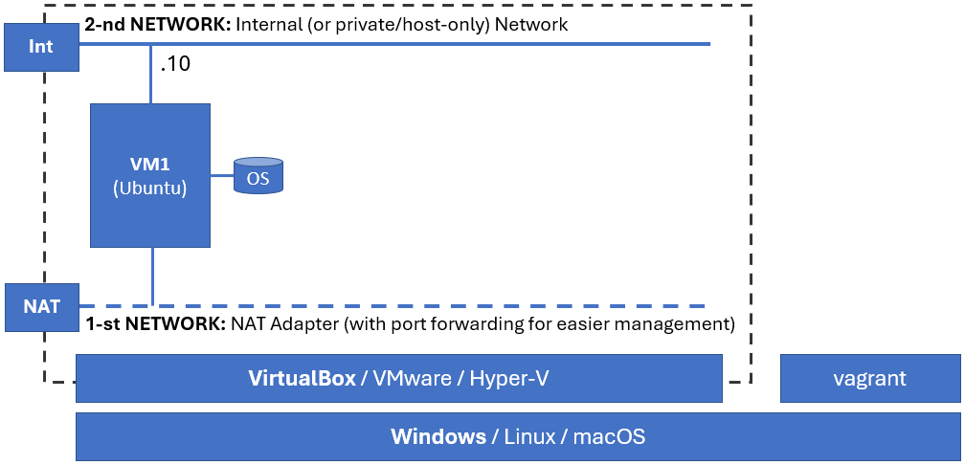
Of course, having an IDE like Visual Studio Code or similar would be nice
You could use your own Ubuntu-based (or compatible) VM or start one via the provided Vagrantfile (it spins up a VirtualBox VM)

Preparation
Extract the files provided with the module
Navigate to the target folder
Open terminal session
Start the VM
vagrant up
Open an SSH session to the VM
vagrant ssh
Update repositories and installed packages
sudo apt update && sudo apt upgrade -y
You may need to reboot the VM after the upgrade is completed
Now it is a good time to create a snapshot of the VM. It will allow us to return this clean updated state whenever we need it. Of course, we can always delete the VM and start fresh. Use whichever is easier and more convenient
Should you want to create a snapshot and are using the provided Vagrant-based VM, exit the SSH session and execute
vagrant snapshot save default
Once the snapshot is done, return back to the VM
vagrant ssh
Last, but not least, copy the extracted files in the home folder of the user in the VM
cp -vR /vagrant/apps/ ~

Python Samples

Python Counter App
Explore the app in the ~/apps/python-counter-1 folder
Once done, return to the console
Install the required Python packages
sudo apt install -y python3-pip
Navigate to ~/apps/python-counter-1
Initialize the virtual environment
python3 -m venv .venv
Activate the virtual environment
source .venv/bin/activate
Install the required modules
pip3 install -r requirements.txt
Start the application
python3 app.py
Open a browser and go to http://192.168.56.10:5000
Refresh a few times - the counter increases
Return to the console and press Ctrl+C to stop the application
Start it again with
python3 app.py
Return to the browser and refresh - the counter starts again from 1. Why?
There are multiple ways to solve this issue, but we will explore just one of them
Stop the application
Deactivate the virtual environment
deactivate

Python Counter App #2 (with Redis)
To make the counter persistent, we will use external storage, in our case Redis
Install Redis by executing
sudo apt install -y redis-server
Check the status of the service and if it is not started, then start it
systemctl status redis
Now switch to the ~/apps/python-counter-2 folder
Explore the code and identify the changes compared to the previous version
Initialize the virtual environment
python3 -m venv .venv
Activate the virtual environment
source .venv/bin/activate
Install the required modules
pip3 install -r requirements.txt
Start the application
python3 app.py
Open a browser and go to http://192.168.56.10:5000
Refresh a few times - the counter starts from 1, but with each refresh increases by 1
Return to the console and press Ctrl+C to stop the application
Start it again with
python3 app.py
Return to the browser and refresh - the counter continues from where we left off
Stop the application
Deactivate the virtual environment
deactivate

Python Counter App #3 (with MariaDB)
Install MariaDB by executing
sudo apt install -y mariadb-server mariadb-client
Secure the installation
sudo mariadb-secure-installation
Check the status of the service and if it is not started, then start it
systemctl status mariadb
Now switch to the ~/apps/python-counter-3 folder
Explore the code and identify the changes compared to the previous version
Initialize the database
mariadb -u root -p < ~/apps/db/db.sql
Initialize the virtual environment
python3 -m venv .venv
Activate the virtual environment
source .venv/bin/activate
Install the required modules
pip3 install -r requirements.txt
Start the application
python3 app.py
Open a browser and go to http://192.168.56.10:5000
Refresh a few times - the counter starts from 1, but with each refresh increases by 1
Return to the console and press Ctrl+C to stop the application
Start it again with
python3 app.py
Return to the browser and refresh - the counter continues from where we left off
Stop the application
Deactivate the virtual environment
deactivate

Go Samples
Now we can switch to another language and see how it goes
Either reset the VM or continue, it won't matter much

Go Counter App
Install the Go language packages
sudo apt install -y golang-go
Navigate to the ~/apps/go-counter-1 folder
Explore the code
It may resemble, at least a bit, what we already know from the Python sample applications
Return to the console
Initialize and create a new go.mod file
go mod init go-counter
Adjust the go.mod file to match the source code in the module
go mod tidy
Start the application
go run main.go
Open a browser and go to http://192.168.56.10:8080
Refresh a few times - the counter increases
Wait a bit. It skips values. How is this possible?
Let's examine what is actually happening and why we see this behavior
While in the browser, open the Developer Tools, switch to Network and refresh the page
There, you will notice two requests - both are normal and expected (sort of)
Then, what is wrong?
Check out the details and more specifically the Status code - it is 200 for both requests
200 is good, but why do we have issue then?
Because on the request for the favorite icon, our application is answering as there is one (and there is none), but instead of the icon, it returns the web page we normally see. This leads to increase in the counter not by one, but by two
Stop the application by pressing Ctrl+C
And switch to an improved version

Go Counter App #2
Navigate to the ~/apps/go-counter-2 folder
Explore the code
Return to the console
Initialize and create a new go.mod file
go mod init go-counter
Adjust the go.mod file to match the source code in the module
go mod tidy
Start the application
go run main.go
Open a browser and go to http://192.168.56.10:8080
Refresh a few times – the counter increases
This time it works as expected – increases by 1
But what will happen if we stop and start the application again?
Let's do it
Stop the application by pressing Ctrl+C
And start it again
go run main.go
Return to the browser and refresh - the counter starts again from 1. Why?
There are multiple ways to solve this issue, but we will explore just one of them
Stop the application

Go Counter App #3 (with Redis)
Let's use Redis for tracking the visits
You must install it first, especially if you reset the VM
If you have it from previous exercise, skip the following commands and skip to the application
Install Redis by executing
sudo apt install -y redis-server
Check the status of the service and if it is not started, then start it
systemctl status redis
Navigate to the ~/apps/go-counter-3 folder
Explore the code
Return to the console
Initialize and create a new go.mod file
go mod init go-counter
Adjust the go.mod file to match the source code in the module
go mod tidy
Start the application
go run main.go
Open a browser and go to http://192.168.56.10:8080
Refresh a few times - the counter starts from 1 and increases by 1 with each consecutive refresh
Stop the application by pressing Ctrl+C
And start it again
go run main.go
Return to the browser and refresh - the counter continues from where we left off
Stop the application

Go Counter App #4 (with MariaDB)
Let's use MariaDB for tracking the visits
You must install it first, especially if you reset the VM
If you have it from previous exercise, skip the following commands and skip to the application
Install MariaDB by executing
sudo apt install -y mariadb-server mariadb-client
Secure the installation
sudo mariadb-secure-installation
Check the status of the service and if it is not started, then start it
systemctl status mariadb
Initialize the database
mariadb -u root -p < ~/apps/db/db.sql
Now switch to the ~/apps/go-counter-4 folder
Explore the code
Return to the console
Initialize and create a new go.mod file
go mod init go-counter
Adjust the go.mod file to match the source code in the module
go mod tidy
Start the application
go run main.go
Open a browser and go to http://192.168.56.10:8080
Refresh a few times - the counter increases like a charm
Have you noticed something about the starting value? Especially if you went over the Python examples first
Stop the application

Go Counter App #4 (Compiled)
One last thing - Go applications could be, and usually are, compiled
Let's compile our last application and run it
Make sure you are in its folder - ~/apps/go-counter-4
Compile the application
go build -o counter-app
And run it
./counter-app
Open a browser and go to http://192.168.56.10:8080
Refresh a few times - of course, it works
Stop the application

NodeJS Samples
As additional pair of samples, there are two versions of the same application but implemented in NodeJS
Feel free to try them as well
If NodeJS is new for you, use the following few commands as a starting point
Install NVM to manage NodeJS versions
curl -o- https://raw.githubusercontent.com/nvm-sh/nvm/v0.40.3/install.sh | bash
Adjust the environment
export NVM_DIR="$HOME/.nvm"
[ -s "$NVM_DIR/nvm.sh" ] && \. "$NVM_DIR/nvm.sh" # This loads nvm
[ -s "$NVM_DIR/bash_completion" ] && \. "$NVM_DIR/bash_completion" # This loads nvm bash_completion
Make the changes available in the current session
source ~/.bashrc
Install the most recent NodeJS version
nvm install node

NodeJS Counter App #1
Navigate to the folder
Create a package.json file
npm init -y
Install the required packages
npm install express
Start the application
node app.js

NodeJS Counter App #2
Navigate to the folder
Create a package.json file
npm init -y
Install the required packages
npm install express redis
Start the application
node app.js

Database Exploration
Should you want, you can use the following section as a starting point to explore either of the two databases

Explore Redis
Consider the following collection as a simple cheat sheet
Get information about the default local Redis instance
redis-cli info
Start an interactive CLI session against the default local instance
redis-cli
Ask for information (just like you did on the command line)
INFO
Get all keys in the default database (db0)
KEYS *
Ask for the value of the hits key
GET hits
Ask for the value of another the key – go-hits
GET go-hits
Check the size of the database
DBSIZE
Delete all keys from the database
FLUSHALL
Quit the interactive CLI session
QUIT

Explore MariaDB
Consider the following collection as a simple cheat sheet
Connect to default local MariaDB instance
mariadb -u root -p
Switch to the counters database
use counters;
Get the list of all tables in the selected database
show tables;
Ask for all rows from the hits table
select * from hits;
Delete all rows from the hits table
truncate table hits;
Quit the interactive CLI session
quit

